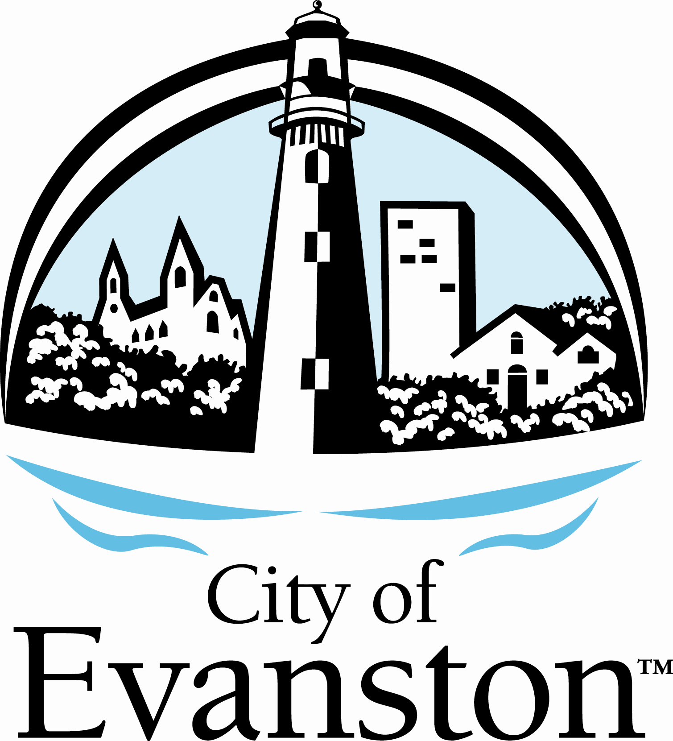

Ryan Field Rebuild Community Engagement Services

RFP # 23-20

ADDENDUM No. 1

March 28, 2023

Any and all changes to the Request for Proposal are valid only if they are included by written addendum to all potential respondents, which will be emailed prior to the proposal due date. Each respondent must acknowledge receipt of any addenda by indicating in its proposal. Each respondent, by acknowledging receipt of addenda, is responsible for the contents of the addenda and any changes to the bid therein. Failure to acknowledge receipt of addenda may cause the submittal to be rejected. If any language or figures contained in this addendum are in conflict with the original document, this addendum shall prevail.

This addendum consists of the following:

- Addendum Number One (1) is attached and consists of a total of four (4) pages including this cover sheet.

Please contact me at 847-866-2971 or johngonzalez@cityofevanston.org with any further questions or comments.

Sincerely,

John Gonzalez
Purchasing Specialist

Ryan Field Rebuild Community Engagement Services

RFP # 23-20

ADDENDUM No. 1

March 28, 2023

This addendum forms a part of RFP #23-20 and modifies these documents. This addendum consists of the following:

Questions 1 to 5 are from the March 21, 2023 pre-proposal meeting. This meeting also covered RFP 23-19 and some of these questions may pertain to that RFP only.

- Question: How would we scope out in price the interaction with the community engagement
specialist? Is the expectation that we would complete our study, put together our numbers and just hand over the report to the community engagement specialist, answer any questions they have, and then that’s it? Or are we expected to be part of all of their presentations?

Response: The plan is for your report to be handed off to the community engagement specialist who will use your report to devise their process. Once the economic impact findings have been determined (either preliminary or final), we expect the impact consultant to draft summary findings and “hand off” to the community engagement consultant to share and seek community input in the context of the findings. It is possible that the economic impact study consultant may need to present findings at community meetings structured by the engagement consultant. Please scope accordingly.

- Question: If the community engagement and the economic impact processes are separate, is there a process that the city will take to get the results of the economic impact out to the community? Or is that meant to be part of the community engagement specialists work as well?

Response: The City will use its resources to distribute the findings. Coordination with the
community engagement consultant will be critical to align communications accordingly. The city will not prescribe the process.

- Question: Is it okay if we just put in hourly rates for if the selected community engagement
specialist wants us present?

Response: Yes, that would be helpful. Please include any additional costs that might arise for your services that you feel maybe necessary. These additional costs can be listed as part of the total project costs or as optional but please make sure to provide an itemized total for the entire project.

- Question: You mentioned, four community engagement events. Are you anticipating that’s exactly what you want or are you looking for the respondents to suggest things and should those events apply specifically to the four communities you want to engage?

Response: The total community engagement events are unknown but four communities were initially identified. If there are more events needed, it will be determined or recommended by the engagement specialist.

- Question: Is there a set budget?

Response: We do not currently have budget details. Please provide realistic costs/budget for
your services to complete the project.

Questions 6-11 were submitted directly to the project team.

- Question: In Section 1.0 Introduction, the RFP calls for separate engagement processes with Central Street businesses, Ryan Field residential neighbors, 7th Ward community members, and Evanston citywide community members. Section 2.0 Scope of Services mentions four scheduled community engagement events. Are you looking to limit engagement to four events, or may respondents submit additional engagement methods to reach the four target communities as well as hard-to-reach groups? Is your thought that the four community engagement events would serve the dual purpose of presenting the results of the economic impact study and gathering community input on the findings?

Response: The City did not intend to prescribe the community engagement process other than the requirement to engage four distinct communities - Ryan Field Neighborhood, 7th Ward, Central Street Businesses, Citywide.

- Question: Is the certificate of insurance naming the City of Evanston as an additional insured due with the proposal or upon signing of a contract?

Response: The certificate of insurance is due upon signing of the contract.

- Question: Do the City of Evanston M/W/EBE utilization requirements apply to contracts of any size? If the prime contractor is an M/W/EBE, do the requirements for subcontractors still apply?

Response: M/W/EBE is a goal, not a requirement. Participation is encouraged for all contract sizes when applicable. If the contactor is certified M/W/EBE and will be subcontracting a portion of work, the contractor will only receive credit for the contract amount not being subcontracted. If their subcontractors are also certified M/W/EBE, they will also receive credit for those amounts.

- Question: Do you have a general idea of participation numbers that you expect for each event community engagement event?

Response: We do not know how many to expect at any of the meetings.

- Question: It mentions in your proposal document that you "will conduct a nationwide search for a qualified consultant team" - does this explicitly mean that vendors outside the United States are disqualified? Our firm is based in Vancouver, Canada.

Response: We will accept international proposals.

- Question: If the answer is yes to the above question, do you accept consortiums or a dual bid with a collaborating partner (which would be based in the U.S.)?

Response: Yes.

Note: Acknowledgment of this Addendum is required in the Submittal.

