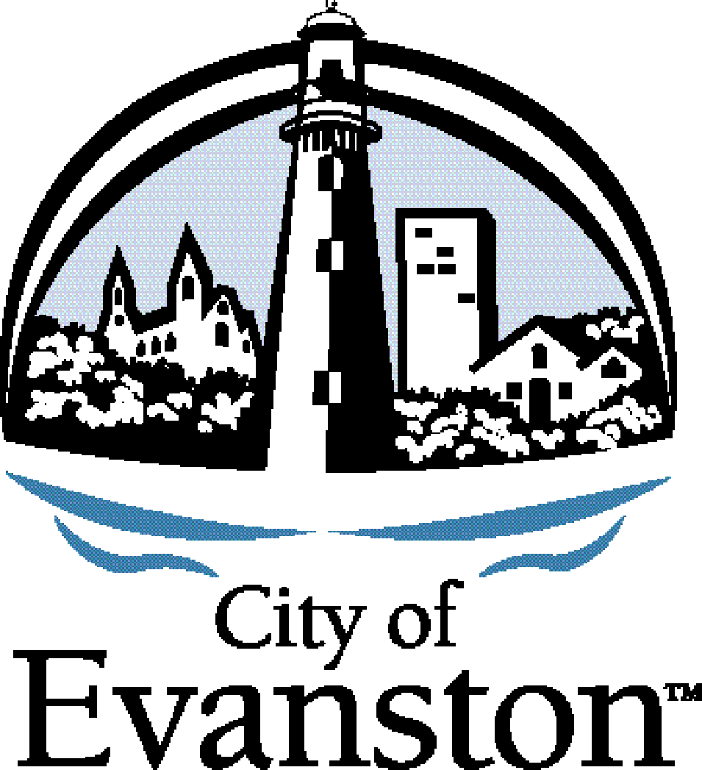

**Evanston Arts Council Meeting**

Tuesday April 10, 2018 6:30 p.m.

Lorraine H. Morton Civic Center, 2100 Ridge Avenue, Room 2404

**AGENDA**

1. **Call to Order and Declaration of a Quorum**
2. **Public Comment** – Mr. Robinson
   1. **Mr. Andrew Tinucci and Ms. Lara Biggs** Presentation on plans for the new Robert Crown building. (Public input on artwork to follow.)
   2. **Ms. Ginny Ching Yin Lo** Funding proposal, Identity Dance
   3. **Mr. William Eason** Funding proposal, Art of Evolution Theater.
3. **Approve Meeting Minutes** – Ms. Degliantoni
   1. March
4. **Staff Report** – Ms. Lasik
5. **C3 Report -** Ms. Degliantoni
6. **Public Art Subcommittee** – Ms. Riseborough
7. **Policy Working Group** - Mr. Robinson
8. **Old Business** – Mr. Robinson is absent
   1. Review Work Plan-have another retreat? nobody has any update, May, June facilitator. It was suggested to do a doodle poll for May June subcommittee. Ms. Deglianton asked if any one wants to be in a working group for a work plan day. Nobody was interested.
9. **New Business** 
   1. Discussion regarding public art for Robert Crown building.
10. **Adjournment**

**Next meeting will be May 8, 2018**